# 40 Years of Graphics

Bill Barnes

### Davidson technology in the “old days”

#### More on movies

I also was a projectionist with the same 35 mm projectors that my brother used. I think by then the rent for the movies we got was 50% of the gate. Since the distributor didn’t specify an “appropriate” admission, we set the price at $1.00 or 75¢ in 1970. I remember one movie that had a couple scenes with topless women dancers in the background. You could hear the splices running through the projector where each projectionist had cut out a couple frames for himself.

When they tore down the Ovens Union (to build the Little Library) and retired the 35 mm projectors I grabbed a lens and a few feet of film (I think it’s from the trailer to *Dr. Strangelove*) and maybe a reel. It’s somewhere around in my attic.

That experience got me a job one summer at Carowinds showing a 70 mm roller-coaster film. I was the only one on the crew who could splice film.

### On methods of reproduction

#### Personal background

At least since my grandfather our family has been blessed (or cursed) with a need to participate in epistleography – as evidenced by this thread. Being amateurs at the craft, we had to find our own means of enriching the Post Office for distributing our irregular family letters. While some of the family put multiple carbons in their typewriter (occasionally forcing recipients to use a mirror to read this week’s letter), our father introduced me (about age 8) to the [hectograph](https://en.wikipedia.org/wiki/Hectograph).[1] I assumed it was a poor-man’s substitute for a spirit duplicator but it actually has an entry in the 21st-century Wikipedia. With that as a kickstart, I was fascinated with the process of printing. While in high school I took an enrichment class that gave me access to the darkroom and platemaking process for offset printing.

#### On (and off) campus printing

For a period of time (1972-73 I think), I was the chief photographer† for the student newspaper, the *Davidsonian*. That gave me the excuse to go across the street to the town paper’s print shop and monitor the preparation of the week’s photographs. Since the paper was printed on a letterpress[2] the process used technology that dated to soon after the Civil War (as did possibly some of the equipment in the shop). Any type or image had to be raised as the ink would be applied only to the highest part of the letters. The shop had two Linotype machines to set the body text and other systems for headline-size type.

Photographs had to be *mechanically* engraved on a sheet of plastic. The photo was attached to one end of a drum and the plastic to the other. As the drum spun, a photocell would scan the photo and a pin punched the plastic to create the halftone dots.

Since this process took 10 minutes or so to scan a photo, I would wander back and write and set headlines for inside stories. The headline sizes of standard fonts were hand set from California Job Cases. Except the cases held molds which were then injected with lead to produce a solid line. Often I would compose more than one headline as my first might be rejected by the editor. It didn’t matter – the lead just went back in the pot for the next edition.

While the Linotypes were interesting for their 19th century complexity; I was more fascinated by the printing press. It was a *hand-fed* flat-bed double broadsheet size (approximately 25” x 45”) letterpress. The operator would pick up a sheet of newsprint and float it into the impression section of the press. Automatic mechanisms extracted the sheet and inked the type ready for the next sheet.

They also had a machine the shape of a 30-inch-wide spinet piano cased in metal with a typewriter keyboard. It made a chirping sound somewhat like the Linotype, but instead of lead, its product was a piece of photo paper with text on it. At the push of a button, it could create “type” in eight fixed sizes from 6 pt. fine print to 36 pt. headlines. But it was only useful for the new-fangled offset duplicator in the office. And without having to haul the lead pots, it could be run by a *girl!*

---- ----

The college also had a poster shop on campus while I was there. Other than peering in an open door, I had no involvement with it. In addition to wooden type and proof press as might have been used in the 18th century, they could make stencils and use spray paint. One time a group I was associated with decided to print our names on T-shirts. We set the names in modest-sized type and mounted it in the press. Except the shirts were black and we couldn’t get enough white ink on it for a good image.

I did have one of the poster shop’s more artistic movie cards taped to a file cabinet at home for many years. It probably got lost in a move, but may still be on the side of a file cabinet that’s up against another.

### 40 years of printing technology

#### Personal notes

My first full-time job was working in the bindery at a small offset print shop. After a few weeks the boss pulled me over and said that before he hired me he had recently hired an employee who was laid up soon after starting work and had come back. Although he’d rather keep me in the position, the other man was entitled to it. I said “no hard feelings, call me back when you get an opening in the pre-press area.”

In a couple months I was doing layouts and brought my darkroom skills so the company could make their own line negatives and didn’t have to send out for all their films.

One day we came in and our office had been rearranged to make room for a new machine. It was a Compugraphic *Compuwriter 88* (1977)[3] – the successor model to the phototypesetter I’d seen in Davidson 4 or 5 years earlier.

#### My business

Within a few years, a coworker left the print shop to start a typesetting-only spinoff for another printer. I soon joined her (1979) and, as her interest turned to babies, bought her out (1980). For the next 15 years I listed myself as a typographer and president of a small business – with 1-3 employees.

My market was to provide quality cold type (phototype) and simple layouts (pasteup) to small printers, printing brokers, and a few independent designers. I also had a few end consumers who were performing all the services of a printing broker for their own business.

I found that most of the ad agencies big enough to have “account execs” required more instantaneous capability, varied services, hand-holding, and, honestly, quality, than I was capable of providing. They generally had more flexibility in what they were willing to pay, but I didn’t find it worth the trouble.

Calling myself a “typographer,” I felt the important product was the words. Many of the “commercial artists” would tack their design layout on the wall, stand back 3 feet, and squint at it to assess the “color” and “flow” of the piece. They didn’t notice that the type was too small or the run-around too obscure to read. One designer actually wanted me to reverse * a registration form over a dark photograph. I refused on the premise that I doubted many people would have a white pen to fill it out.

In the early 1990’s the business of small print shops – and their support services – was drastically changing. With the ubiquity of photocopiers, desktop computers, and affordable laser printers, much of the work that once required specialized equipment could now be performed in any moderate-size office. In fact, one of the typesetting equipment manufacturers had an ad that “your secretary can set type.” Yeah ... right. For an investment of $10,000 and up in equipment and a year or two experience. This ain’t a *Selectric* typewriter, honey.

OK. That was snarky. But in reality, whether by my customers or an office employee, a lot of the work we did could be produced at a “good enough” level with a lot less capital.

From the mid-1980s, I did try to move more of the typesetting process to commodity computing equipment. By using some (inexpensive compared to Compugraphic’s offerings) third-party software and a basic multiple search-and-replace translation template that I wrote, we were able to import PC-created text into the typesetter with basic formatting already included. This meant that with a little training for the typist we could produce an organization’s newspaper-length publication without tying up our skill and equipment.

A client recommended I check out a pioneer desktop publishing[4] program - *Ventura Publisher*.[5] It was a page layout hybrid environment using *markup language* that required a GUI* (Digital Research’s GEM) for its preview mode and used an early competitor to Microsoft’s Windows. Between a lack of demand in my market and insufficient time to teach myself, I never used it.

I also bought Aldus *Pagemaker* that came with a run-time version of Microsoft Windows 1.0. Because entry was made directly on the page layout it was easier to self-learn. Unfortunately, neither Windows ver. 1.0 nor the second generation PCs computers had sufficient power for it to be productive.

With the advance to Windows 3.0 and 3.1 and Intel ‘386 based PCs, I was able to acquire competence in both *Pagemaker* and the *CorelDraw!* graphics program. With these programs I could recreate some simple logos and basic newsletters. I even attempted to use the power of the PC to integrate a (commercial products) catalog with a price list database so updating one component would automatically flow into the other.

Unfortunately I did not buy the high-end interface between a PC and the imagesetter and could not support high quality output from customer supplied files.

Eventually technology overtook us and business dropped off. During 1995 I released my layout and camera person and took over those responsibilities while my wife did most of the typesetting. In January 1996, we closed the business except for projects in process.

#### The technology

When I bought the business, we were using the *Compuwriter 4* – bigger brother to the *Compuwriter 88*. All of the early basic models allowed the operator to key in one line of copy, plus font choice and size parameters. It had a single line dot matrix display (visualize the classic Time’s Square news ticker) that showed the last 24 (or so) characters you had entered. You could replay the entire line from start to finish, but not pause or edit it. When you pressed Enter, the line was imaged onto photo paper and memory was flushed as it had no storage of previous typesetting.

We soon advanced to the *Compugraphic Editwriter* (1980)[6]  which had a small CRT display and 8” floppy disc storage. This allowed storage of jobs so they could be corrected or used as templates or boilerplate without need to recreate the entire job.

For all of these typesetting machines the master image of the characters existed in a single size on a high-resolution strip of film. Each filmstrip for this line of typesetters could have up to four fonts; * eg: regular, italic, bold, and bold italic of one family such as Helvetica (except Compugraphic did not have a license for Helvetica and instead offered a clone). If a family did not have a complete set of styles or if a shop had need for a particular mix, custom combinations could be ordered.

The filmstrips were mounted on a spinning drum that was synchronized with a strobe that fired as the image of a letter came by. Then the carriage was indexed across the photo paper to image the next character. A turret of fixed focal length lenses determined the size of the type. Compugraphic did not use zoom lenses that hypothetically could create an infinite number of sizes, because the fixed lenses were more accurate and absolutely consistent. Character width and kerning information was on read-only memory in a cartridge that was inserted along with the filmstrip. All of these operations were controlled by a computer with the same Z80 CPU that was in my 1978-vintage Radio Shack TRS‑80.

The *Editwriter* allowed you to queue a job to the imaging unit and concurrently work on a new job (they both had to reside on the same data disc). An experienced operator could have a sense of where in the job the imaging process had progressed to from the sound. The chirp of the strobe was subtly different as it indexed across the line depending on the size of the type. Also, the act of changing fonts or lenses was a significant mechanical process. It was not unusual for the operator to suddenly abort the output process because of an error such as failing to change a size or font.

Somewhere around this time I went to a pitch for an advanced typesetter from Compugraphic competitor AM. The gee-wiz hype was that they were using an Apple *Lisa* running Aldus *Pagemaker* as the front end. The downside was that the *Lisa* alone cost $10,000 and the imaging units were comparable to the *MCS* offerings. But you did have access to the original licensed fonts while Compugraphic could only offer clones for a large part.

Our next quantum leap in technology was the *Compugraphic MCS* [7] (1983). This physically separated the input and output devices. The more capable operating system using the common 5-1/2” floppy discs facilitated multiple operators and even 3rd-party plug-ins that allowed offline job creation.

The basic *8200* imaging unit fonts used a similar concept, but incompatible system of film masters and character alignment details on 8” discs as the *Editwriter*. We soon upgraded to the *8400*. It included a “huge” 80 MB hard drive that could store its OS, buffered jobs, and more fonts than I could afford. Since it created the characters on a CRT, it could produce special effects such as font distortion (artificially extended or slanted type), reverse print, and column rules.

All of the imaging units used a rubber pinch roller to move the photo paper from a feed box into a take-up cartridge with each line return. They also could be instructed to roll the paper back. This allowed you to create columns, or place blocks of information left and right on a business card. Unfortunately there is some slippage in the vertical feed which is worse the farther you move it up and down. Although the front end software allowed you to create a newspaper page flowing from column to column, there was no assurance the columns would perfectly align. Even setting type straight down the page was not accurate enough for a critically accurate step-and-repeat[8] or form.

-----

All of the front end entry environments used a *markup language* (visualize HTML without CSS). All of the keystrokes were displayed onscreen as a continuous string in the system font. The typographic commands were manually inserted in-line with the copy. The only visual semblance to a WYSIWYG * display was greying the commands and a return at line endings. Thus the start of this paragraph might appear onscreen as:

<FT3><PS10.2><LS12><LL1800><QL><EM><EN>All of the front end entry environments used a <FT4>markup   
language<ft3> (visualize …[9]

Fortunately the keyboard had special keys for the most common commands and a set of programmable keys that could enter a string of custom commands (and/or text, if desired) with a single keystroke. On the *MCS* the keyboard programming could be saved on disc as a file to load when needed for a particular template.

Later Compugraphic offered a preview add-on to allow the operator to see a representation of the final layout on a separate monitor. But, after over 10 years’ experience with the technology, we were competent enough to visualize the final product by reading the code. I became proficient at designing and laying out complex forms in code without needing to see the actual page. I still miss some functions from the typesetting system that can’t be easily accomplished in common word processor or desktop publishing programs.[10]

#### The industry

While I was in business the printing industry in Charlotte was somewhat inbred. Many of the operators might have worked together (or for each other) at another shop or a supplier to the industry. It was not rare for me to hear of a new shop and drop in to introduce myself. I’d start my pitch to the counterperson and shout out “hey Joe” as I recognized the manager in the back.

Although my clientele were all competitors and could be cutthroat when it came to their customers, they showed professional courtesy when someone was in a bind. If equipment was down or they ran out of supplies, there was a good chance the company down the street would help them out. There also were fewer suppliers than printers so they might encounter each other in my office. I had to be very circumspect when someone would bring in a job that I had created for another shop.

Small printers would produce what they could in-house and subcontract other work to larger shops in the city or across the country. Some specialized in particular products such as business cards, large format or full process color * (a high-end product at that time). While the larger full-service operations did have their own sales reps, their clientele would often not be the end user but ad agencies, independent designers, brokers, and smaller copy shops.

My clients were mostly small copy shops with 3-10 employees, including the owner(s) who were often a couple. Some were franchisees of a national chain and supported each other in adjacent territories. Two had been police officers and when one made good the other chose the same next career. A few were direct spin-offs of another printer with cross-ownership.

The shops would have 2-3 presses capable of printing a sheet up to 11”x17”. Maybe one press was capable of printing two colors in a single pass. They also had photocopiers; sometimes high-volume, sometimes basic depending on their needs. Anything that their equipment could not handle, they would send out to another provider.

Other clients were a single person working as a broker who used various suppliers appropriate to the needs of a particular job. They could buy typesetting from me, give basic jobs to a copy shop, buy forms from a local company, and business cards from a specialty plant in Omaha.

A few printers were lone retirees who had a single press in the garage and would need typesetting once a month. There were also some very capable graphic designers who specialized in one type of job and I would see the same needs repeatedly.[11] Others were single-client brokers or in-house designers. They brought a variety of jobs for the same customer.

Some of my better customers were end users. Their business generally involved major documents where the same material was customized for each client. Think commercial property leases or promotional packages for one industry. One of my last such clients developed promotional games to boost (or maintain) newspaper subscriptions. He died in the middle of one campaign and I had to complete that week’s game in his image before it was turned over to the paper itself.

Even so, some end users were a pain to serve. They didn’t know what they wanted. Or they knew exactly what they wanted and wouldn’t accept that I couldn’t do it. Or it couldn’t be done at a cost they would want to pay. Sometimes someone I’d never seen before would dash in near the end of the day that they needed to change something at the last minute. Since they represented a major organization and seemed sincere, I let them walk out with an invoice. Usually it was no problem, but occasionally I never got paid.

#### Anecdotes

One government agency was willing to pay after I sent them a past due. But they needed the “original” invoice to pay. My work order was a 2-part form. The top sheet was labelled “INVOICE” and the copy was our “WORK ORDER.” I made a copy of what I had and mailed it to them. No, they wanted the “original invoice.” Of course, the person who ordered the job carried that off. I finally gave up, deciding I’d spent more trying to collect than I would get paid.

When a mentor of mine retired he brought me a memento that had been in his lobby as long as I’d known him. It was a litho stone† – an artifact from the first decades of the 20th century – that I would turn over in my hands whenever I dropped in on him. He gave it to me and said no one else would appreciate it. I practically wept at the gift.

### The last 20 years

When we closed the business, I joined a client who was installing his own electronic pre-press department. His business dealt largely with agencies and was capable of producing many-page booklets and full-color jobs up to 20”x28”. That was a disastrous year and a half for me since my market had largely been small 1- and 2-color jobs and the work was beyond my experience.

I left that for some futile attempts to find employment as a typographer. When I gave that up I decided on a career change. A more successful career was providing office computer support working through temp agencies. My last offer was a 1-year guarantee at an industrial site. I retired from there 15 years later.

Without regard to my earlier experience, my final computer support job was in a printing plant! Actually, their market sector was “folding cartons” (visualize – cereal boxes). I was at best peripherally involved in supporting actual printing, but still took an interest in the technology and how it was different, and the same, as my earlier career.

They still printed individual sheets of heavyweight paper on standard offset presses. Instead of working with presses that could print an 11”x17” sheet, these presses could go up to 28”x40” and print 4-1/2 colors at a time (more later on the “1/2” color)[12].

The engineer in me is always fascinated by the process. I would occasionally pause just to watch the machines run.

The paper came on 3,000-5,000 lb. rolls that was cut to the size required. After a sheet was printed, it usually was die-cut to the shape of a flattened-out box. Then it would be partially folded and glued and packed to go to the customer where it could be set up, filled, and closed up with glue or tape.

This plant’s product was mostly “short run” jobs while larger orders would go to another location. But in the commercial industry, “short run” frequently applies to 100,000 or fewer units.[13] One repetitive job’s orders would be one million or more units. But over 50 copies could be printed on a single sheet, so one million units were just 20,000 sheets – a couple hours’ press time.

By sheeting their paper from the roll, they could cut it any size they needed. During my tenure I saw them redesign their plates and dies so the sheet for a given job would be as little as one inch smaller. The savings in paper was sufficient to pay for the change of design.

Also, when I came, the platemaking process started when film negatives came from an outside supplier. Skilled local staff would mount the negatives for each color on a carrier sheet. Each color had to be attached exactly the same way to the carrier so they would line up correctly on the press. The negatives then go in a machine that exposes the individual films multiple times across the plate in a step-and-repeat.

Before I left, the entire plate making process had been digitized. Instead of negatives the company graphics department would transmit a file with the completed printing plate to a local computer server. If there was any problem with the design, a phone call to the graphics department would send the corrected file back to their server in a few minutes or hours.

The server transmitted the job to a laser imager that created the printing plate just like in my typesetter from 30 years previous. Except this output was not a 6-inch wide roll of paper. It was a 50-inch wide piece of aluminum. A CAD file was similarly sent to a flat-bed plotter fitted with knives to cut holes in the blankets used to coat the product with varnish.

I worked with the staff to document the steps and write up a procedure that allowed the press department to remake a plate in a pinch. Then the company was able to eliminate personnel in the department during off-shifts.

---- section ----

---------------------------------------

* A glossary follows the endnotes [14]

† Illustrations [15]

---- section ----

---- page ----

1. Hectograph: <https://en.wikipedia.org/wiki/Hectograph>
2. Additional reading on the processes of letterpress printing; in no particular order...  
   Linotype: <https://en.wikipedia.org/wiki/Linotype_machine>  
   Hot type: <http://www.moah.org/virtual/printing2.html>  
   Halftones: <https://en.wikipedia.org/wiki/Halftone>   
   General information: <https://www.prepressure.com/printing/processes>   
   
3. Dates “(1977),” etc. represent when I encountered the referenced technology or change, not necessarily when it was publicly available.
4. Desktop publishing is an environment to arrange text and graphics in a layout that represents the final page. Depending on the needs, it can be as simple as a modern word processor or complex enough to produce a periodical or book. Basic programs can run on contemporary PCs while larger documents with involved graphics and photos may require more capable processing power and servers.
5. Ventura Publisher: <https://en.wikipedia.org/wiki/Corel_Ventura>
6. In fact, when I bought the *Editwriter*, it came with 2 days’ onsite training. When it was delivered I called the company to send the trainer. They said he’d be there in 2 weeks. So I unpacked it and turned it on.

   When the trainer came I showed him one of the jobs I was playing with and said “here’s what I did and how I did it, but it seems inefficient. Can you show me the correct way to accomplish this?” His response was “I didn’t know that machine could do that!”

   But I had several years’ experience with less capable equipment that, nonetheless, had the same commands available where I had learned how to extract the most from what it could do. Needless to say, the trainer gave me an hour’s instruction in care and maintenance and left.
7. Compugraphic Corporation: <https://en.wikipedia.org/wiki/Compugraphic>
8. Step-and-repeat is the process of printing multiples of the same or different copy the same size down or across the page. For example, filling out a sheet of die-cut labels is a step-and-repeat.
9. Decoding the markup:

   <FT3><PS10.2><LS12><LL1800><QL><EM><EN>All of the front end entry environments used a <FT4>markup   
   language<ft3> (visualize …

   <FT3> Font #3 – Helvetica regular in my system

   <PS10.2> Size 10-1/2 points (The *MCS 8400* imager could size type in 1/4 point increments entered as “decimal” 1, 2, or 3 quarters)

   <LS12> Line space from baseline to baseline of characters 12 pts

   <LL1800> Line length 18 picas (3 inches)

   <QL> Quad Left – aligned on the left margin and ragged on the right

   <EM><EN> Indent with the typographic EM and EN unit widths

   <FT4> Change to font #4 – Helvetica italic
10. The 60 or so fonts in our catalog were arbitrarily numbered. When they were programmed into the front end and imagesetter they were assigned the same font number. The same fonts in another shop with identical equipment would likely have different numbers.

    I haven’t used modern desktop publishing programs lately, but my wish list for 21st century formatting commands include:   
    • fill the remaining line length – effectively “justifying” the line – with [white space or a repeated character] rather than word space. It can be used multiple times and divides the spaces equally.  
    • floating tabs – define a horizontal space from here  
    • justify within a tab  
    • vertical justification
11. One would typically buy 5-10 *words* at a time. They were always in a plain bold type but he was very specific about relative height and width they should be. He laid out billboards. I still look at billboards and observe that they don’t work at 60 MPH.

    Another graphic designer specialized in food labels, particularly milk cartons. These had very specific legal requirements for the information and minimum size of type. They often had to fit in a very small space so the type had to be ultra-condensed.
12. What’s the “1/2” color? The presses had 4 full offset units with printing plates that transfer the inked image to a rubber blanket that actually contacts the paper. The last section before drying has only a blanket that puts a uniform layer of varnish over the whole sheet to add scuff-resistance or sheen. If you cut holes in the blanket, those areas will not get any varnish. This technique is used so there’s no varnish where the carton will receive glue or at-fill-time printing such as expiration date or lot number.
13. When I was working in a copy shop, a customer came in wanting some roll labels. He was asking for something around 50,000 individual labels. (In our small press sheet-fed experience, 10,000 was a big and rare order.) We knew nothing about roll labels, but there was a company in my neighborhood that specialized in roll labels. I contacted their rep he laughed at me. He said it took 100,000 just to get the press set up.

    Of course, this was decades before the internet and businesses that could sell you one custom printed t-shirt for barely more than the cost of the shirt.

    ---- section ----
14. * **GLOSSARY**

    **GUI**  
    Graphic User Interface – A computer screen beyond green text on black using a selection device such as a mouse. *Example* Microsoft Windows.

    **Font**  
    A distinctive typeface such as Helvetica or Palatino. Also, designed (as opposed to distorted such as slanted or overstroked) varieties of that typeface such as italic or bold. Since most fonts are copyrighted or trademarked there may be a cost to use it. Companies that did not own popular fonts might create similar knockoffs such as Microsoft’s Arial – a substitute for Helvetica.

    **Hot type**Printing images that are physically higher than the surrounding material so only the desired areas are covered with ink to transfer to paper. The “hot” comes from the production method of molding the image from molten lead.

    **Process Color**Full-color printing such as a photograph. This is produced by the use of 4 specific colors of ink: cyan, magenta, yellow, and black which are referred to as CMYK.   
      
    Process color contrasts to **spot color** which uses individual colors of ink as a highlight.

    **Reverse type**  
    The process where the shape of the type is presented as a hole in an image such as a photo or other mostly solid ink. The result is that the paper (or a background color) shows through the image.  
      
    Generally the effect is that you see “white” type over the image.

    **WYSIWYG**  
    What You See Is What You Get  
    The page on the computer screen is a reasonable representation of what will print, including type styles, line breaks, and position.
15. † **IMAGES**

    Just to brag – my most republished photo:  
    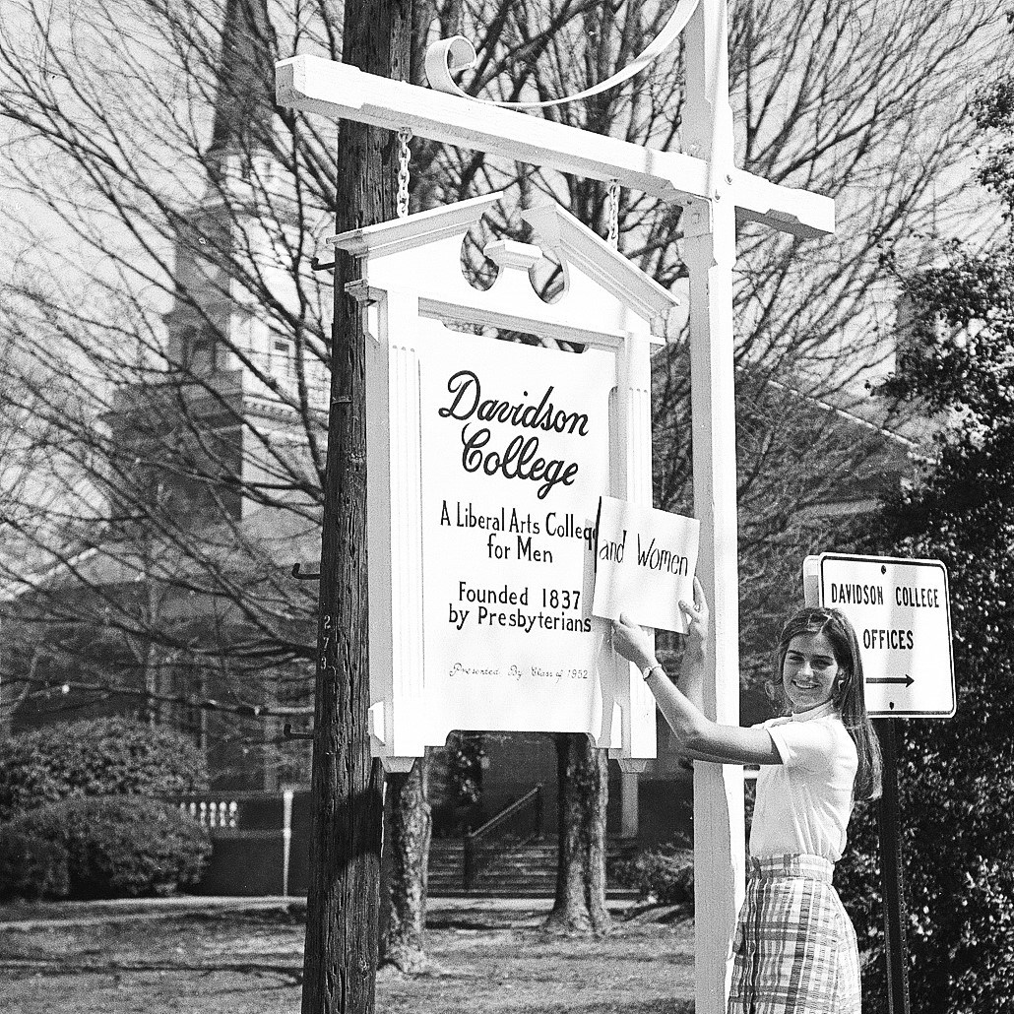  
    This was used uncredited in college publications and publicity for years. Over three decades later we were walking through a museum exhibit when my wife caught my arm and said “there’s your picture.” Finally, about 2017, I asked the school to associate my name with their master – which I originally sold for $3.

    ... and the full frame – from my negative:  
    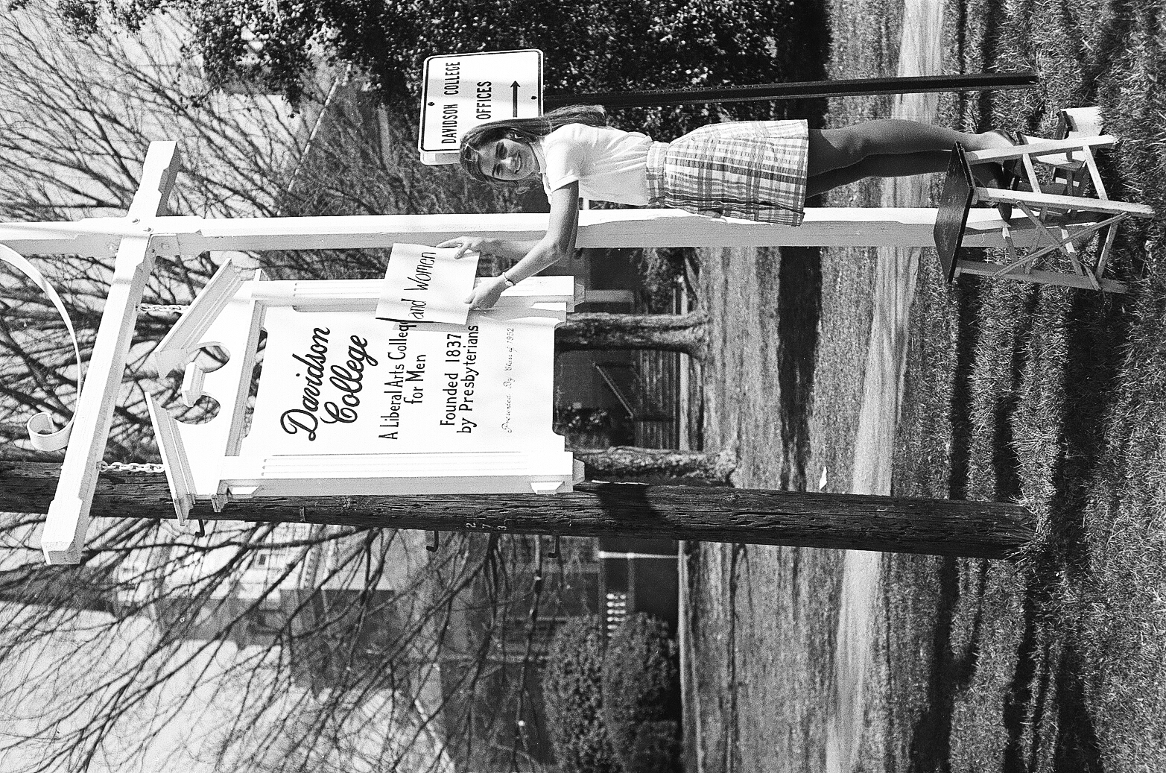

    The litho stone:  
    